Practical No:10
Configuring ASA Basic Settings and Firewall Using CLI

Network:
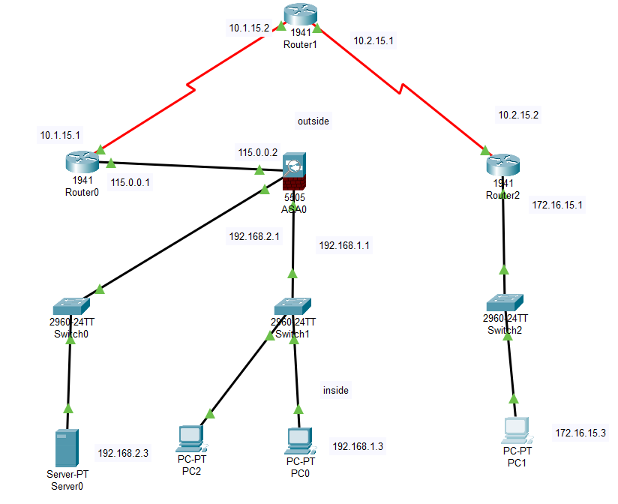

IP Addressing Table
Device | Interface | IP Address | Subnet Mask | Default Gateway
R1 | G0/0 | 115.0.0.1 | 255.255.255.248 | N/A
 | S0/0/0 (DCE) | 10.1.15.1 | 255.255.255.252 | N/A
R2 | S0/0/0 | 10.1.15.1 | 255.255.255.252 | N/A
 | S0/0/1 (DCE) | 10.2.15.1 | 255.255.255.252 | N/A
R3 | G0/0 | 172.16.15.1 | 255.255.255.0 | N/A
 | S0/0/0 | 10.2.15.2 | 255.255.255.252 | N/A
ASA | VLAN 1 (E0/1) | 192.168.1.1 | 255.255.255.0 | NA
ASA | VLAN 2 (E0/0) | 115.0.0.2 | 255.255.255.248 | NA
ASA | VLAN 3 (E0/2) | 192.168.2.1 | 255.255.255.0 | NA
DMZ Server | NIC | 192.168.2.3 | 255.255.255.0 | 192.168.2.1
PC-0 | NIC | 192.168.1.3 | 255.255.255.0 | 192.168.1.1
PC-1 | NIC | 172.16.15.3 | 255.255.255.0 | 172.16.15.1

Configure ASA Settings and Interface Security Using the CLI

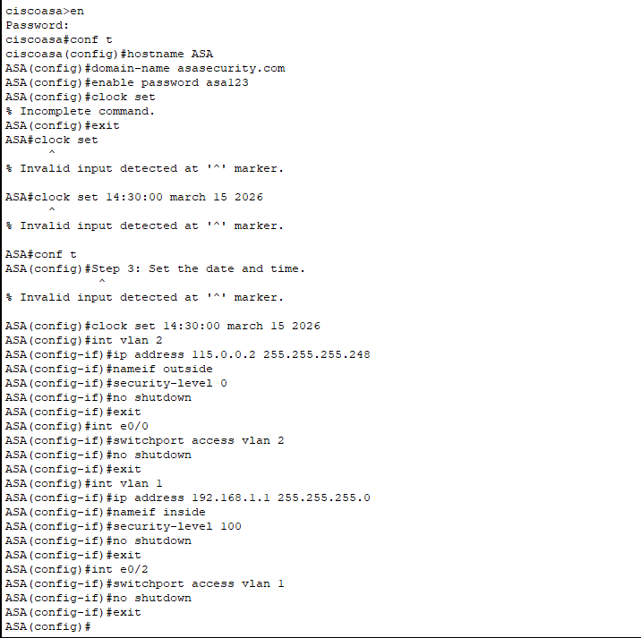

Configure the inside and outside interfaces.


Configure Routing, Address Translation, and Inspection Policy Using the CLI
Configure a static default route for the ASA.
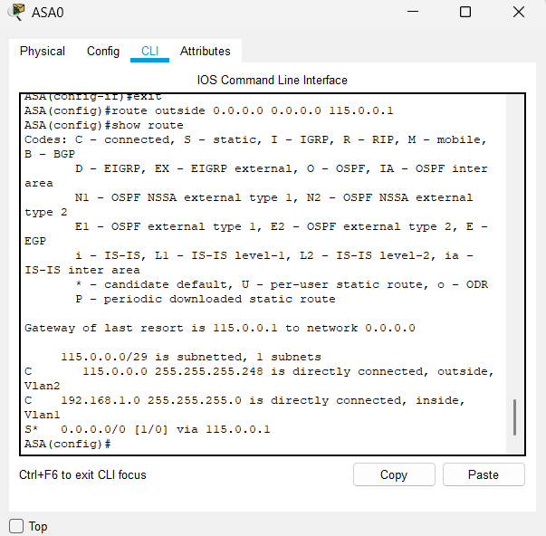

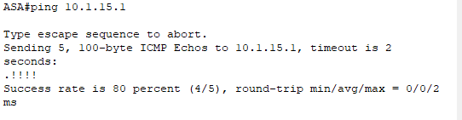

Configure address translation using PAT and network objects.
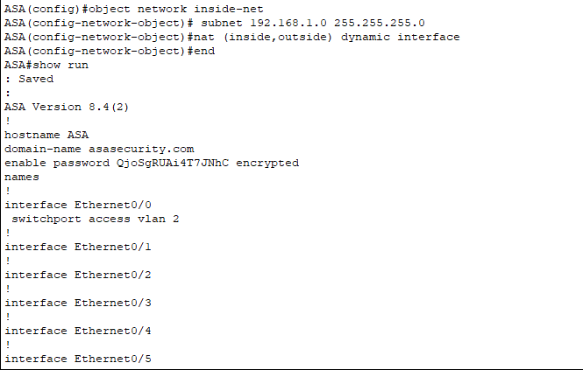

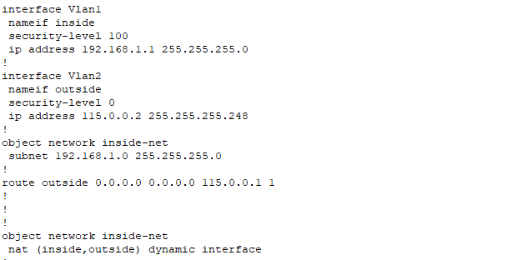

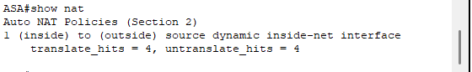

Modify the default MPF application inspection global service policy.
- ASA uses MPF (Modular Policy Framework).
This allows the firewall to: inspect packets, track connections, prevent malicious traffic
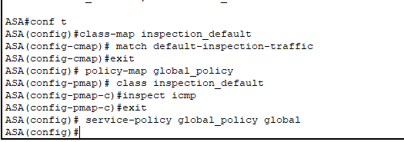

From pc0 ping 115.0.0.1 (Connectivity Testing)
NAT is working,routing is correct and firewall allows the traffic
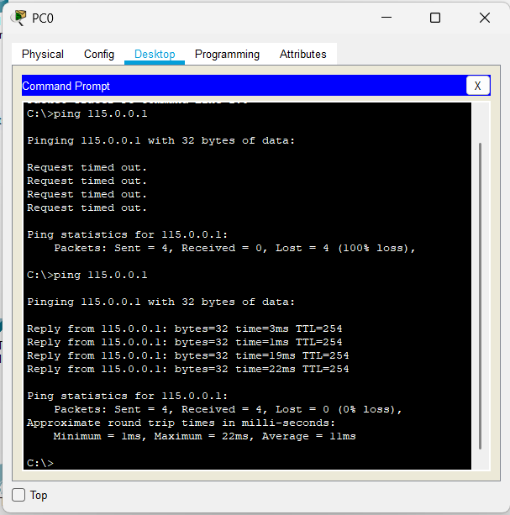

Configure DHCP, AAA, and SSH
Configure the ASA as a DHCP server.
ASA automatically assigns IP addresses to inside hosts.
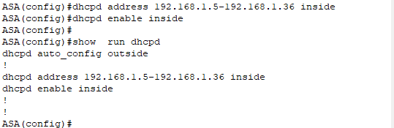

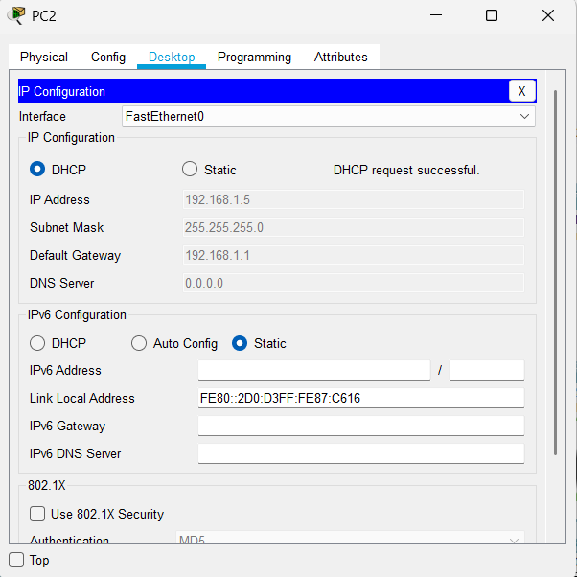

Configure AAA to use the local database for authentication.
Allow only authorized users to access the firewall.
Configure remote access to the ASA.
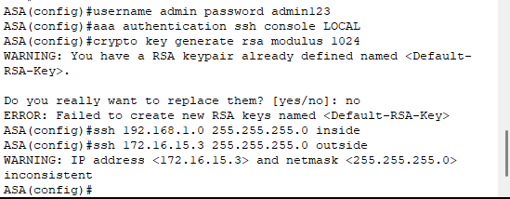

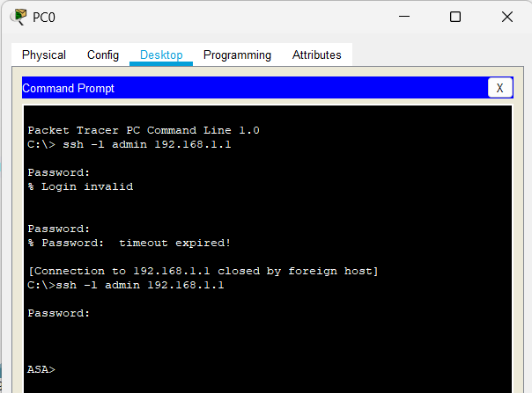

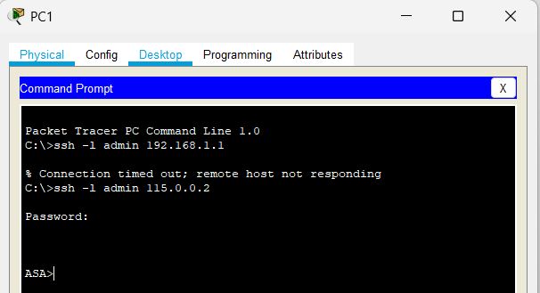

Configure a DMZ, Static NAT, and ACLs
Configure the DMZ interface VLAN 3 on the ASA.
A DMZ (Demilitarized Zone) network is created.
It protects the internal network even if the server is attacked.

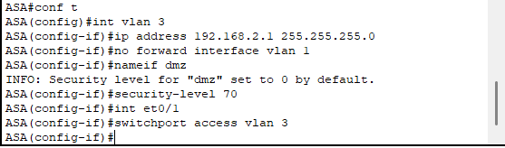

Configure static NAT to the DMZ server using a network object.
Allows external users to reach the server safely.
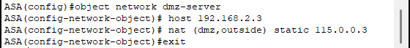

Configure an ACL to allow access to the DMZ server from the Internet.
ACL is configured to allow internet users to access the DMZ server.
HTTP to DMZ server(allowed)
Direct access to inside network(blocked)
